Introduction:

The project we have chosen was the text based adventure game and we have decided that our game would be an RPG dungeon crawler which would include a player going through different rooms and fighting different unique enemies and would also be able to interact with NPCs and be able to upgrade their gear by either buying them from a shopkeeper or collecting them by defeating mini bosses.

Our team has 4 members included and they are:
- Alex
- Sophia
- Zahari
- Logan

System Design:

During the planning phase of the project, we have created a Grantt chart, flowchart and a critical path analysis and we have also assigned each member tasks to do in the Grantt chart.

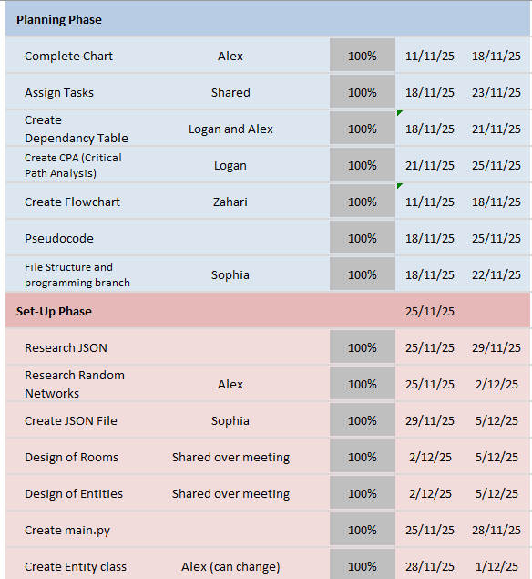
On the Grantt chart here is the tasks assigned for each member and also there is the start date on the left and the deadline on the right. Usually, it is expected that the member finishes the task around the deadline it doesn’t have to be that specific date obviously this could be due to reasons such as busy with other modules.
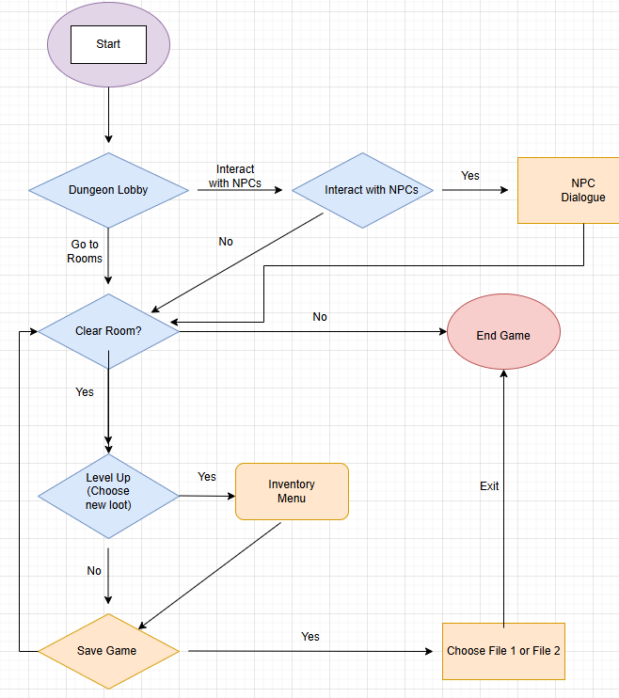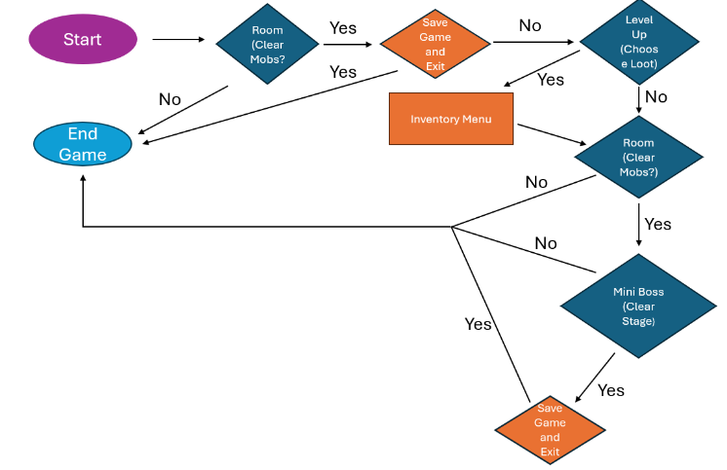

Here are the two flowchart designs that were created for the program and it should be important to point out that the design on the right was scrapped in favour for the design on the left because it had to be redone on a more stable software rather than on Microsoft PowerPoint and the idea is to give an overview of how the game would function and the rooms of course the program doesn’t have to stick to this but it’s supposed to give a direction of where to go from the planning phase into the programming phase.

Implementation:

After initial planning, Alex gave out tasks to everyone to do and rather than doing the whole program in one main file the group decided to do the program into separate files and then join them together with a path finder this is because having the whole program into one file would be a nightmare because 4 people will be editing it and therefore it would be hard for the group to keep up with and debugging it would also take a lot of time because you would have to factor in that the program would have over 500 lines of code and for every time someone edits the program it would instantly need debugging after and therefore splitting the program into individual tasks would be beneficial because that person is responsible for their own work and they would have to debug it by themselves. Although it’s true that the individual has to debug their own tasks it is a team project after all so the individual can ask their peers for help whether that be making an issue on GitHub or asking a simple question on WhatsApp however, it is better to make record communication on GitHub rather than taking screenshots of WhatsApp chats.

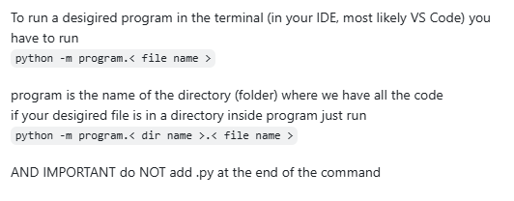
One problem with the program that occurred was an import error that would cause the program to crash therefore the solution to this would be to add an __init__.py file to every folder however everyone would need to add a command that would locate the location of the file inside the function.

In one moment, Sophia was using genesis to create rooms however due to lack of communication Alex repurposed to intro text therefore Sophia could not use it, and it just caused confusion and slowed down time. Another example Zahari was tasked with creating the shop for the shopkeeper and Logan was tasked with creating items and gold drops. Zahari created his own items meanwhile Logan created completely different items which could have also been avoided with proper communication.
In another instance where many files have been dropped in the wrong places for example files for the program have been dropped into the planning branch which was an issue raised on GitHub.

Creating the rooms was Alex’s job and he started off by creating a function that created rooms. Most of it was planning the rooms because Alex had to wait for the NPCs to be created which was one setback because he had to wait on Zahari to create the NPCs first which was time lost because he could’ve been more productive. “Choose room” which chooses the room and create a function to make the player go in the direction they want. Alex also created the player file which gives the player their base stats and tracks the player’s movement and inventory which had to be done before hand. Sophia was also asked to help with the rooms, she was able to fix the function that created the rooms and she created some rooms at once. Sophia has also been helping with creating the rooms and placing the NPC enemies with their dialogue into rooms originally the plan was to have the enemies spawn in a room with a probability however due to lack of time and planning it was decided that the enemies would be put in a specific place and also it was planned to have item drops from enemies however again plans changed and the enemies only drop gold but initially it was decided that they would drop items in a probability.

Zahari when creating the NPCs had to create the script for their lines and he looked up medieval Scottish names to name his NPCs he pitched up the idea to have 3 NPCs to interact with and 2 enemies that have lines to say to the player when they are encountered and they are “the Butcher” and “The Dark Lord”. Unlike the regular NPCs the enemies only say a couple of lines and although there is choice to pick it doesn’t matter in the end because the enemies would attack you anyway. As for the other NPCs you have 3 which are the shopkeeper, informant and gate keeper. The gate keeper doesn’t have much dialogue, but the shopkeeper and the informant have the most lines to say and most of it is gossip about the dungeon the idea is to world build and give the same some lore and make it look interesting.

Testing:

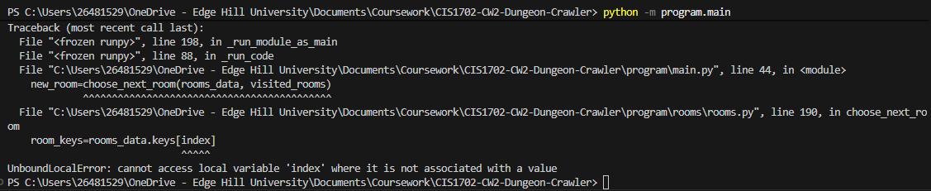
Sophia was tasked with testing the program specifically the room tracking and the rooms which she was tasked with placing the enemies to see if they worked properly.

Breakdown of Contributions:

Alex: Alex was tasked with creating rooms, player, combat, inventory, room tracking

Sophia: Sophia was tasked with creating the JSON file, and function that adds and writes data to the JSON and she was also tasked with helping in odd tasks out for example the rooms

Zahari: Zahari was tasked with creating the NPCs, NPC dialogue and the shopkeeper menu

Logan: Logan was tasked with creating the enemies, gold drops from the enemies and creating items and stats.

Reflection:

One great success that was done would be the structure of the project for example the program was divided into folders rather than putting the whole project into one main python file we have split it up so that each individual member has their own tasks to do and everyone was happy with each task they were given during the planning phase. The idea of this was so that each member was responsible for their own debugging and that they wouldn’t have to debug one giant main file which would be less time consuming and as usual if a member had trouble they could always ask for help by raising an issue on GitHub which worked well because that was used a lot.

Another thing that went well would be the method of communication was great with creating a WhatsApp group chat and also using GitHub issues to raise awareness however, one limitation would be that the fact these methods of communication were not implemented to their best and as a result there was a lot of miscommunication and misunderstandings which could’ve been easily avoided with simple planning and miscommunication however, it was used at times to help peers with debugging and helping out with tasks.
Another thing that was also done well is that the team met up and distributed tasks to each individual and deadlines that was done on a grant chart. Overall, the planning was done well. It was direct and communication was clear and everyone was on board.

Another thing that went well was the standard of the code is that every member was fine with each individual’s work and there were almost no instances of having to rewrite code and which was great for teamwork and in the instances that code needed to be fixed they were sorted out although Alex and Sophia did have different methods of writing code one example is when they disagreed with the JSON file in the end Sophia decided with Alex’s method in order to get it out of the way and the way that issues and pull requests overall was utilized really well and that there is good documentation of the whole project in general in GitHub just from issues which were all able to be closed.

One thing that didn’t go as planned would be the project itself was possibly too unrealistic and that there was too much work to do in the amount of time it was given. What possibly could’ve been done next time would be to make a smaller project and also perhaps it wasn’t enough for 4 people, and another 2 pupils would make the project slightly more realistic however it was also due to the fact that during the holidays the group was quite unproductive.

Another limitation would be that the group didn’t give itself proper deadlines and they mostly had to remind themselves about tasks. One thing to do better next time would be utilize the Grantt chart more and instead of calling or texting each other and ask when will tasks be done and there needs to be a better job done with keeping track of responsibilities.

One limitation would also be that the program didn’t have enough testing done until last minute this could be due to the size of the project because there was a lot of tasks for members to catch up and most of the testing was done in the last couple days.

Conclusion:

Overall, the project taught the team major important communication skills and GitHub skills to use in the future. The program was also able to create the rooms, NPCs, NPC dialogue, room tracking, inventory tracking, player stats and inventory. Overall, most of the important tasks were able to be completed although the planned program wasn’t completed. The group is satisfied with the final result, and the code is functional up to a medium standard.

When programming the project it was clear that there were too many tasks and that the planning was unrealistic and that deadlines were not being achieved and therefore the group decided to stick to what is important and make sure that is it working at the very least with NPCs and dialogue and the hardest part to make sure that the rooms have been created and the inventory tracker with it along too.

Peer Review:

- Your Name: Sophia Tingle
- Your Student ID: 26481529
- Your Group Name: Dungeon Crawler

Teammate 1 Name: Aleksander Pietras

- Contribution and Quality of Work (1-5): 4
- Reliability and Meeting Deadlines (1-5): 5
- Communication and Teamwork (1-5): 5
- Comments (Required):

They took the role of team leader and communicated effectively when giving out tasks and explaining plans. They contributed a lot, although in some circumstances, they spent a large amount of their time on something useless, though it only affected me slightly, so I don’t mind. They were very reliable until the holidays where they went on a trip and was doing a large amount of physical activity every day, and even then, they still made sure to check if everyone was up to date on their tasks, etc. They gave themselves more work than the rest of us and ended up not quite finishing it all, though this was largely due to the timing of other people’s work getting done.

Teammate 2 Name: Zahari Nikolov

- Contribution and Quality of Work (1-5): 5
- Reliability and Meeting Deadlines (1-5): 5
- Communication and Teamwork (1-5): 4
- Comments (Required):

I wouldn’t say there was any issues at all working with them. They contributed suitably in meetings and their code had a high standard. While they may not always have hit the
(somewhat unrealistic) deadlines that were set, by the time I needed to use their code, it was all there, so I have no issues.

Teammate 3 Name: Logan Thompson-Davie

- Contribution and Quality of Work (1-5): 2
- Reliability and Meeting Deadlines (1-5): 2
- Communication and Teamwork (1-5): 4
- Comments (Required):

During meetings and such, they communicated sufficiently. They also explained their challenges both in life (e.g. telling us they were sick and couldn’t do work), and in coding, asking us sensible questions about the work. I would say they were not great at meeting deadlines, as many of us were waiting on them so we could get the main code done, but that only ended up being properly started quite late. When they did push changes, the work itself, was decent, however there were small issues, like the data was not put in the file. Also, I believe we still do not have one of their objectives complete.

- Your Name: Logan Thompson-Davies
- Your Student ID: 26510928
- Your Group Name: Dungeon Crawlers

Teammate 1 Name: Aleksander

- Contribution and Quality of Work (1-5): 5
- Reliability and Meeting Deadlines (1-5): 4
- Communication and Teamwork (1-5): 4
- Comments (Required):

Aleksander was a very effective teammate controlled the development of rooms and the combat system.

Teammate 2 Name: Sophia

- Contribution and Quality of Work (1-5): 5
- Reliability and Meeting Deadlines (1-5): 4
- Communication and Teamwork (1-5): 4
- Comments (Required):

Sophia ran all the debugging and formation of the Json file.

Teammate 3 Name: Zahari

- Contribution and Quality of Work (1-5): 4
- Reliability and Meeting Deadlines (1-5): 5
- Communication and Teamwork (1-5): 5
- Comments (Required):

Zahari ran all the npc interactions and created the shop in our game.

• Your Name: Zahari Nikolov
• Your Student ID: 26579553
• Your Group Name: Dungeon Crawlers

Teammate 1 Name: Aleksander Pietras

• Contribution and Quality of Work (1-5): 5
• Reliability and Meeting Deadlines (1-5): 4
• Communication and Teamwork (1-5): 5
• Comments (Required):

Alex was the group leader he was the one who set up the GitHub page and he was in charge of creating the rooms, room tracking and the player stats.

Teammate 2 Name: Sophia Tingle

• Contribution and Quality of Work (1-5): 5
• Reliability and Meeting Deadlines (1-5): 4
• Communication and Teamwork (1-5): 5
• Comments (Required):

Sophia was mostly in charge of debugging the program because she wasn’t given many jobs to and mostly helped with jobs that needed fixing or that no one wanted to do and she created the JSON file and also worth mentioning that she always had a positive attitude.

Teammate 3 Name: Logan Thompson-Davies

• Contribution and Quality of Work (1-5): 4
• Reliability and Meeting Deadlines (1-5): 3
• Communication and Teamwork (1-5): 2
• Comments (Required):

Feel like he could’ve communicated more overall and that if he needed help we were happy to help and it showed because he didn’t know where to upload his work but at least his work was fine but just needed more done.

• Your Name:
• Your Student ID:
• Your Group Name:

Teammate 1 Name:

• Contribution and Quality of Work (1-5):
• Reliability and Meeting Deadlines (1-5):
• Communication and Teamwork (1-5):
• Comments (Required):

Teammate 2 Name:

• Contribution and Quality of Work (1-5):
• Reliability and Meeting Deadlines (1-5):
• Communication and Teamwork (1-5):
• Comments (Required):

Teammate 3 Name:

• Contribution and Quality of Work (1-5):
• Reliability and Meeting Deadlines (1-5):
• Communication and Teamwork (1-5):
• Comments (Required):

